Accordion Section

Go to layout.html

Copy Template

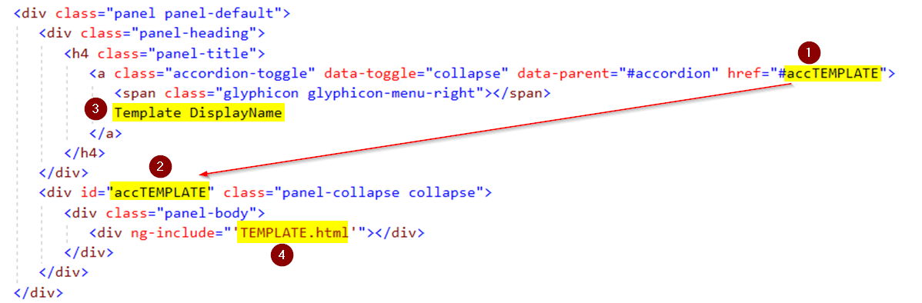

1/2) Change accTEMPLATE

3) Change Template DisplayName

4) Make folder TemplateName under App folder

Add new Controller.js

Copy templateController.js & template.html to new folder & rename

Add Controller to index.html

Add any css also if necessary